# Question:

Write a C program that checks if a given number is an Armstrong number. An Armstrong number is a number that is equal to the sum of its digits each raised to the power of the number of digits in the number.

*#include*<stdio.h>

*#include*<math.h>

*int* *main*() {

*//*

*int* *num* *=* 121;

*int* *temp* *=* *num*;

*int* *temp2* *=* *num*;

*int* *len* *=* 0;

*int* *ans* *=* 0;

*//lenght of number*

*while* (*temp* *!=* 0) {

*temp* *=* *temp* */* 10;

*len++*;

    }

*while* (*temp2* *!=* 0) {

*int* *mod* *=* *temp2* *%* 10;

*temp2* *=* *temp2* */* 10;

*ans* *=* *ans* *+* *pow*(*mod*, *len*);

    }

*if* (*num* *==* *ans*) {

*printf*("\n%d is and armstrong number.",*num*);

    }

*else* {

*printf*("\n%d is not ans armstrong number.",*num*);

    }

*return* 0;

}

## Output:

121 is not an armstrong number**.**

For the input 153:

153 is an armstrong number.

# **Question:** Write a C program that allows the user to input an array of integers. The program should then allow the user to delete an element from the array by specifying its value, shift the remaining elements to fill the gap, and print the updated array.

*#include* <stdio.h>

*void* *inputArray*(*int\** arr, *int* size) {

*printf*("\nEnter %d element of array: \n", size);

*for* (*int* *i* *=* 0;*i* *<* size;*i++*) {

*scanf*("%d", *&*arr[*i*]);

    }

}

*// display an array*

*void* *printArray*(*int\** arr, *int* size) {

*printf*("\nPrinting array: ");

*for* (*int* *i* *=* 0;*i* *<* size;*i++*) {

*printf*("%d ", arr[*i*]);

    }

}

*void* *deleteArrayElement*(*int\** arr, *int* size, *int* target) {

*int* *index* *=* 0;

*for* (*int* *i* *=* 0;*i* *<* 10;*i++*) {

*if* (target *==* *i*) *index++*;

        arr[*i*] *=* arr[*index++*];

    }

}

*int* *main*() {

*int* *arr*[10];

*int* *size* *=* *sizeof*(*arr*) */* 4;

*// input*

*inputArray*(*arr*, *size*);

*//delete element*

*printf*("\n\nSelect array index that you want to delete: ");

*int* *target*;

*scanf*("%d", *&target*);

*deleteArrayElement*(*arr*, *size*, *target*);

*printArray*(*arr*, *size* *-* 1); *//print*

*return* 0;

}

**Output:**

**For input array [1, 2, 3, 4, 5, 6, 7, 8, 9, 10] and deleting element 5, the output would be:**

Enter 10 elements of array:

1 2 3 4 5 6 7 8 9 10

Printing array: 1 2 3 4 5 6 7 8 9 10

Enter element to delete: 5

Printing array: 1 2 3 4 6 7 8 9 10

# Question Name: Delete Element from Array at Given Index

*#include* <stdio.h>

*int* *main*() {

*int* *arr*[10];

*for* (*int* *i* *=* 0;*i* *<* 10;*i++*) {

*scanf*("%d", *&arr*[*i*]);

    }

*int* *target* ;

*printf*("Enter target index: ");

*scanf*("%d", *&target*);

*printf*("\n");

*int* *index* *=* 0;

*for* (*int* *i* *=* 0;*i* *<* 10;*i++*) {

*if* (*i* *==* *target*)*index++*;

*arr*[*i*] *=* *arr*[*index++*];

    }

*for* (*int* *i* *=* 0;*i* *<* 10 *-* 1;*i++*) {

*printf*("%d ", *arr*[*i*]);

    }

*return* 0;

}

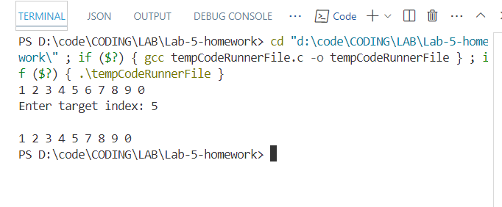

# Question: Insert an Element at a Given Index in an Array

*#include* <stdio.h>

*#include*<stdlib.h>

*int* *main*() {

*printf*("\nEnter size: ");

*int* *size*;

*scanf*("%d", *&size*);

*// enter arr element*

*int\** *arr* *=* (*int\**)*malloc*(*sizeof*(*int*) *\** *size*);

*printf*("\nEnter array element(%d): ", *size*);

*for* (*int* *i* *=* 0;*i* *<* *size*;*i++*) {

*scanf*("%d", *&arr*[*i*]);

    }

*printf*("\nEnter target index: ");

*int* *target*;

*scanf*("%d", *&target*);

*printf*("\nEnter value: ");

*int* *ele*;

*scanf*("%d", *&ele*);

*arr* *=* (*int\**)*realloc*(*arr*, *sizeof*(*int*) *\** (*size* *+* 1));

*size++*;

*int* *index* *=* 0;

*//shifting element form end*

*for* (*int* *i* *=* *size* *-* 1;*i* *>=* *target*;*i--*) {

*arr*[*i* *+* 1] *=* *arr*[*i*];

    }

*arr*[*target*] *=* *ele*;

*for* (*int* *i* *=* 0;*i* *<* *size*;*i++*) {

*printf*("%d ", *arr*[*i*]);

    }

*return* 0;

}

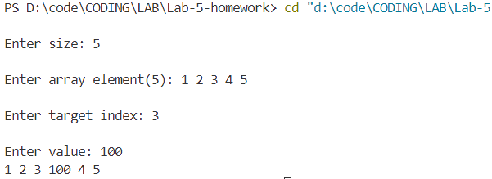

# Question: Array Operations: Input, Sum, Sort, and Delete an Element

*#include*<stdio.h>

*// Input 10 var in a array*

*void* *inputArray*(*int\** arr, *int* size) {

*printf*("\nEnter %d element of array: \n", size);

*for* (*int* *i* *=* 0;*i* *<* size;*i++*) {

*scanf*("%d", *&*arr[*i*]);

    }

}

*// display an array*

*void* *printArray*(*int\** arr, *int* size) {

*printf*("\nPrinting array: ");

*for* (*int* *i* *=* 0;*i* *<* size;*i++*) {

*printf*("%d ", arr[*i*]);

    }

}

*// Sum up the array elements*

*int* *sumOfArray*(*int\** arr, *int* size) {

*int* *sum* *=* 0;

*for* (*int* *i* *=* 0;*i* *<* size;*i++*) {

*sum* *+=* arr[*i*];

    }

*return* *sum*;

}

*// Sort the array element*

*void* *sortArray*(*int\** arr, *int* size) {

*for* (*int* *i* *=* 0;*i* *<* size;*i++*) {

*for* (*int* *j* *=* 0;*j* *<* size *-* *i* *-* 1;*j++*) {

*if* (arr[*j*] *>* arr[*j* *+* 1]) {

*// swap them*

*int* *temp* *=* arr[*j*];

                arr[*j*] *=* arr[*j* *+* 1];

                arr[*j* *+* 1] *=* *temp*;

            }

        }

    }

}

*void* *deleteArrayElement*(*int\** arr, *int* size,*int* target) {

*int* *index* *=* 0;

*for* (*int* *i* *=* 0;*i* *<* 10;*i++*) {

*if* (target *==* *i*) *index++*;

        arr[*i*] *=* arr[*index++*];

    }

}

*// This is*

*// main function*

*int* *main*() {

*int* *arr*[10];

*int* *size* *=* *sizeof*(*arr*) */* 4;

*// input*

*inputArray*(*arr*, *size*);

*// print*

*printArray*(*arr*, *size*);

*// sum of array element*

*printf*("\n\nSum of all array element: %d\n", *sumOfArray*(*arr*, *size*));

*// sort array*

*printf*("\n\nSorting array: \n");

*sortArray*(*arr*, *size*);

*printArray*(*arr*, *size*); *//print after sorting*

*//delete element*

*printf*("\n\nSelect array index that you want to delete: ");

*int* *target*;

*scanf*("%d", *&target*);

*deleteArrayElement*(*arr*, *size*, *target*);

*printArray*(*arr*, *size-*1); *//print*

*return* 0;

}

